# Roll a ball exercise

Evan Williams

Computer game programming- Evett

9-28-2015

Part 1.

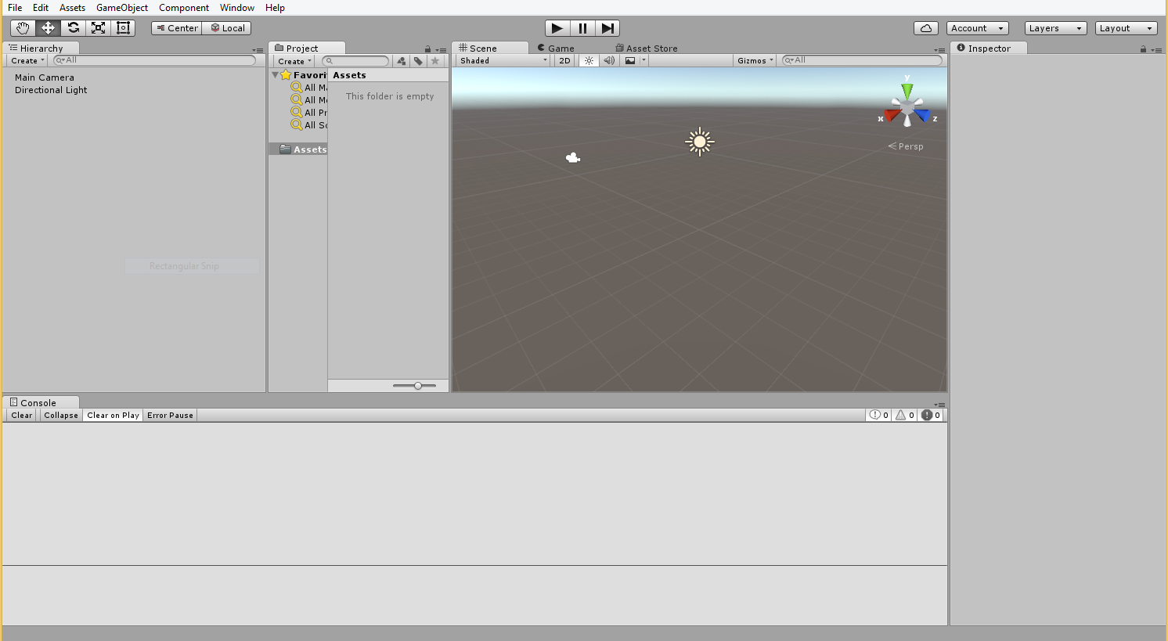

Part 2.

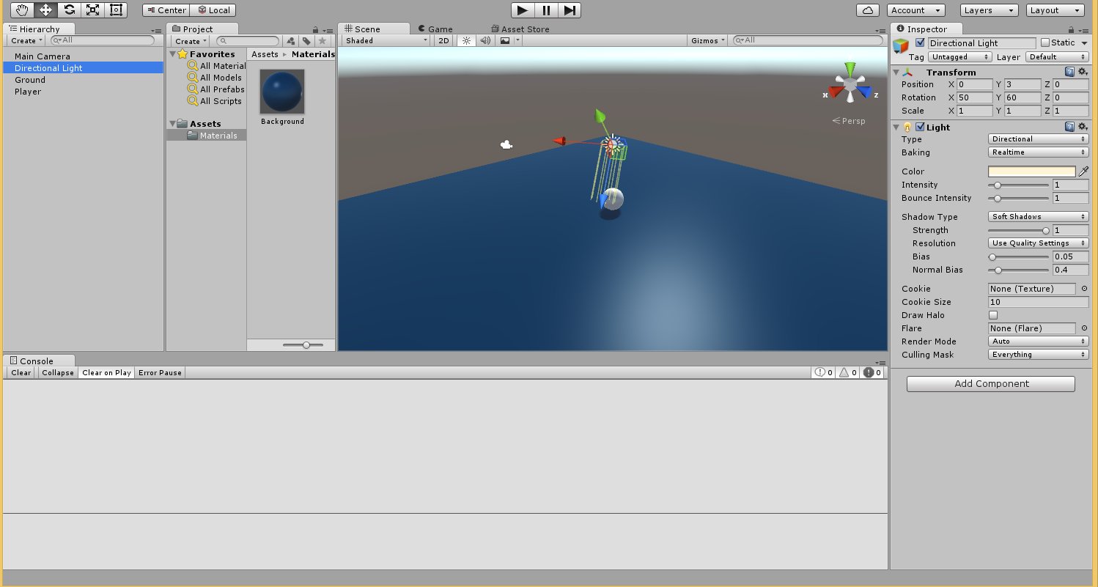

Part 3.

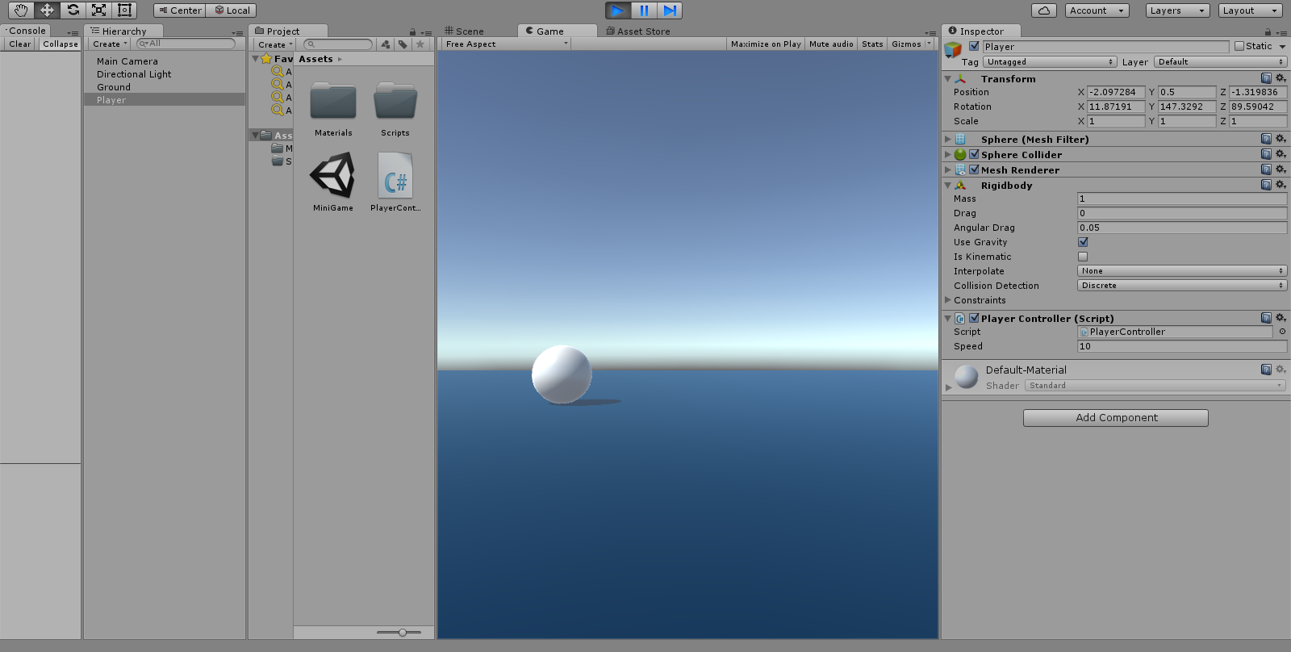

Part 4.

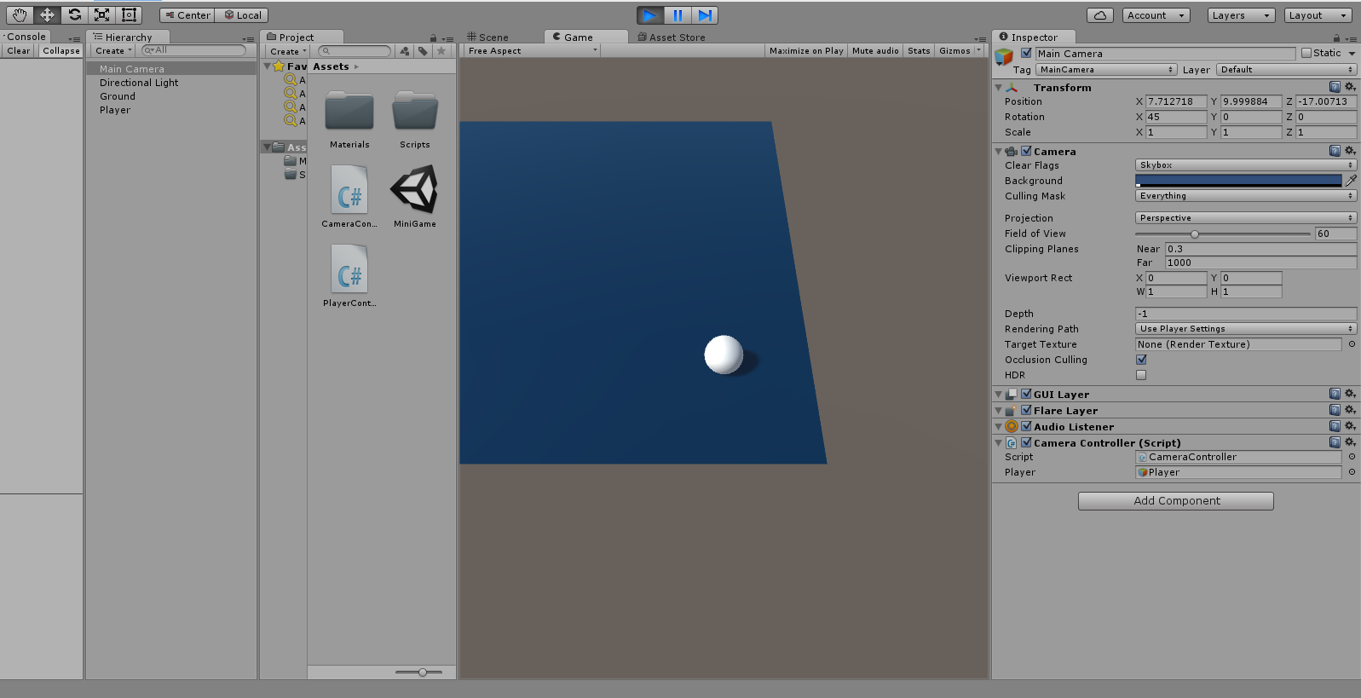

I have never been able to implement a moving player within a game before. This was especially interesting to me since it is the basis of making a playable 3d game.

Part 5.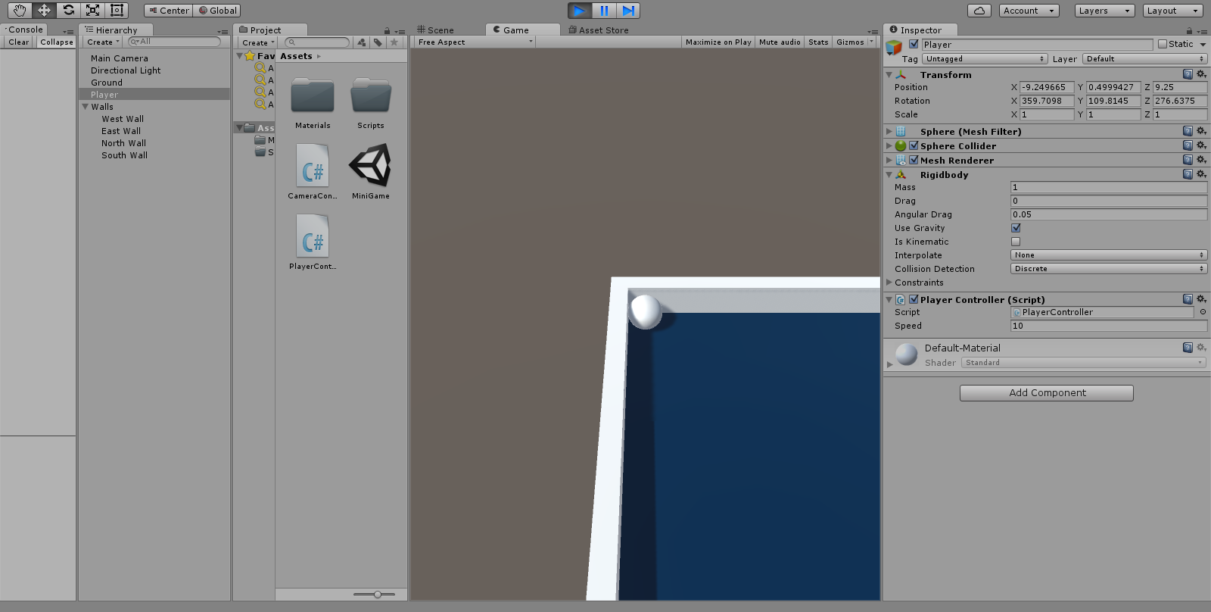

Adding walls is obviously a big part of making a playable gamespace. This was enlighting and it made me think more about regular shapes and how a developer could use math to create flush surfaces and a neat level.

Part 6.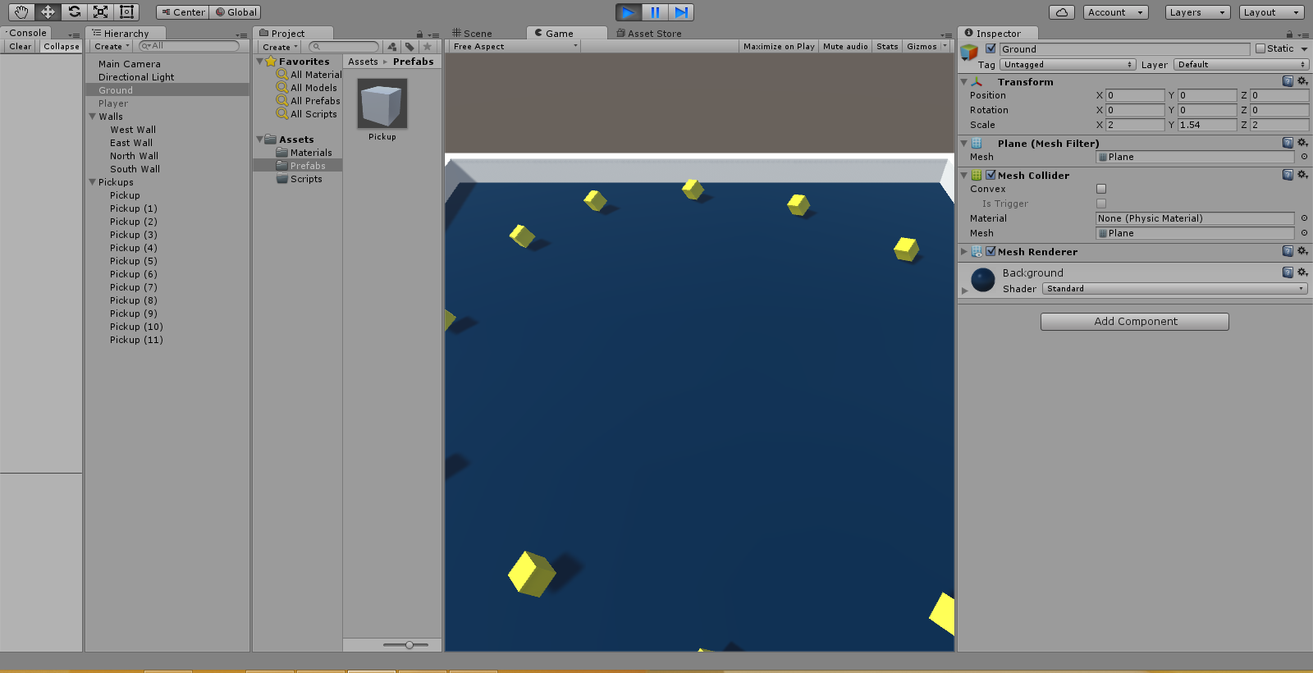

Positioning the pick ups was probably the most time consuming part of the whole proccess but I think with some practice using the unity framework it will be easier to make more symmetric distrubitions of game objects.

Part 7. 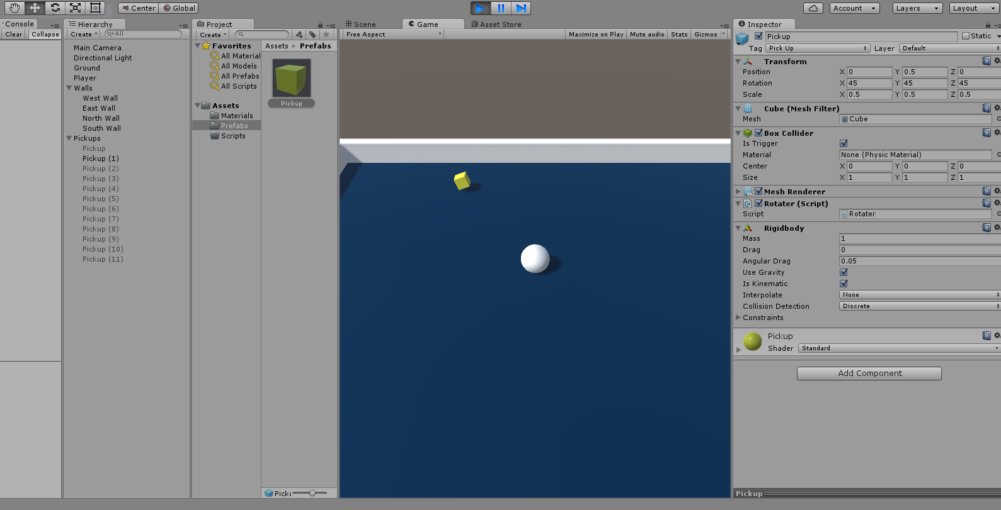

The pick up mechanic was a very interesting addition to this minigame I really enjoyed making a goal for this simple project.

Part 8. 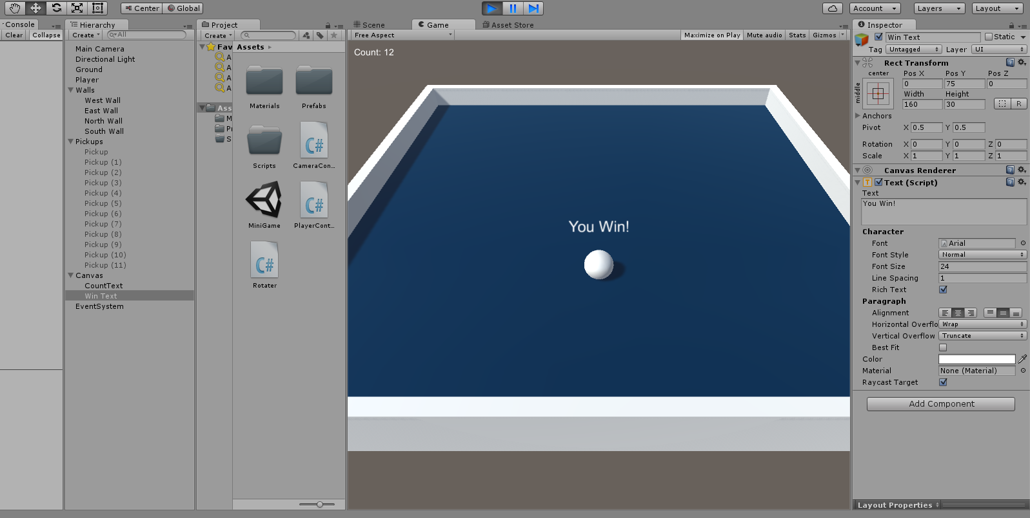

At first I had the colors wrong but I tried again and rebuilt the game and now they are coming out right. I really like how customizable the unity engine is. I only need to learn more about how to implement my ideas.

Part 9.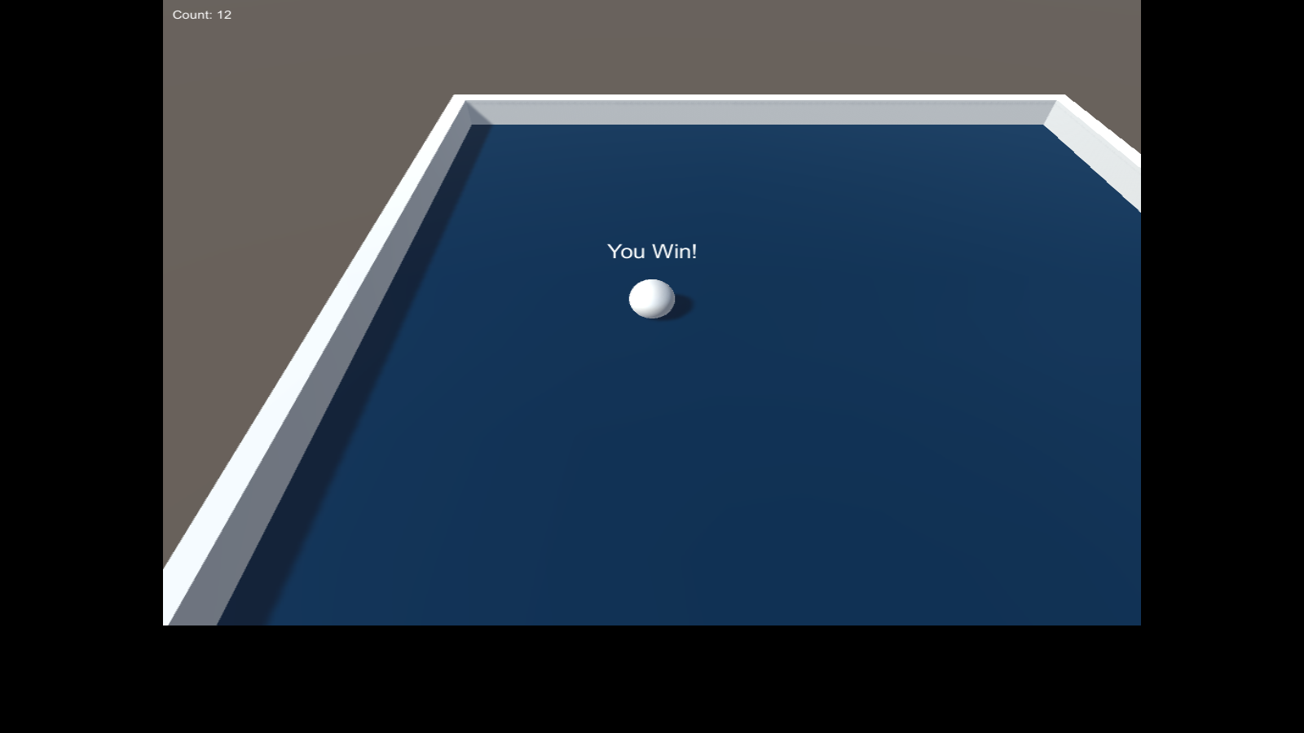

I found the section of video conerning the building of a unity priject into an executable to be very good to know. I was previously wondering how to build a playable game and now I have the knowlage to experiment on my own doing so.